Register no:**1518102067**

Exercise no:**1**

Date:**15/10/2020**

**Aim:** To print the calendar of a given month and year.

**Program:**

import calendar

year=int(input())

month=int(input())

if(year<10000 and year>999 and month<13 and month>0):

print(calendar.month(year,month))

else:

print("Invalid Input")

**Link:**

[**http://103.53.53.18/mod/vpl/forms/submissionview.php?id=229&userid=1682**](http://103.53.53.18/mod/vpl/forms/submissionview.php?id=229&userid=1682)

**Output:**

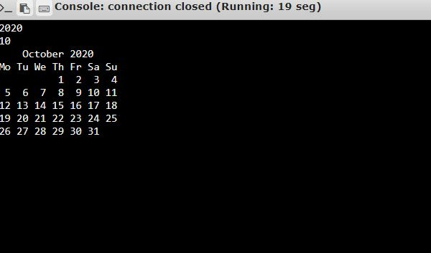

**Result:** Thus the code has been successfully executed and output is verified.